Results

Average SSIM score for image 0: 0.0000

Average SSIM score for image 1: -0.0005

Average SSIM score for image 2: 0.1854

Average SSIM score for image 3: 0.0505

Average SSIM score for image 4: 0.2808

Average SSIM score for image 5: 0.4072

Average SSIM score for image 6: 0.2640

Average SSIM score for image 7: 0.2772

**Our best Image worthy of praise from 5.nii:**

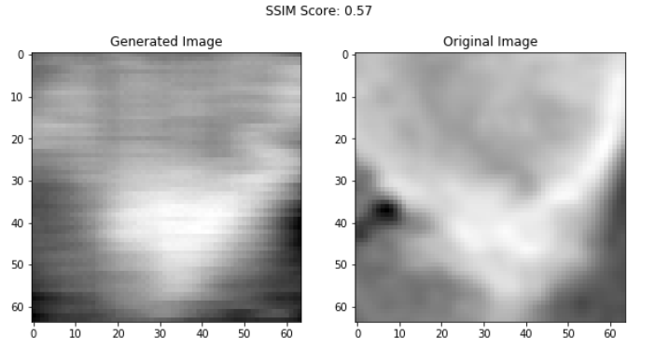

Now for other images,starting from 2 bcoz 0 and 1 are shit:

**2.nii:**

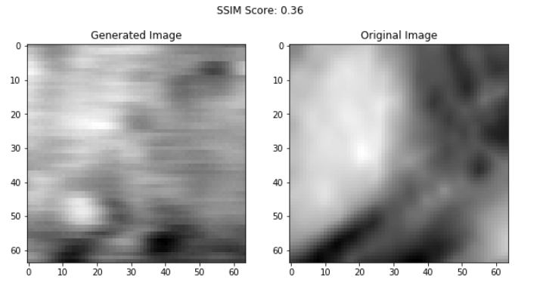

3.nii:

4.nii:

5.nii:



6.nii:

7.nii:

